Contact should be made directly with the relevant agency below depending on the Nature of complaint:
AGENCY | RESPONSIBILITY | NATURE OF COMPLAINT | CONTACT
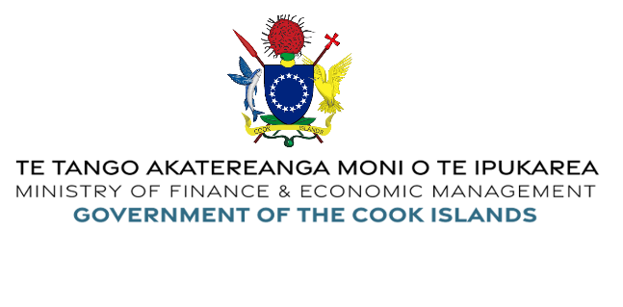 | The Ministry of Finance and Economic Management (MFEM) is a central agency in the Cook Islands Government responsible for advising Government on financial and economic issues. There are seven Divisions within the Ministry: Office of the Financial Secretary; Economic Planning;  Revenue Management; Development Coordination; Major Procurement & Projects; Treasury Management and the Cook Islands Statistics Office. | - Responsibilities imposed by Legislation administered by MFEM.  - Incorrect application of MFEM Policies and Procedures.  - Taxation Assessments.  - Purchasing and Tender irregularities.  - Financial Mis-management.  - Staff conduct.  Legislation  - PERCA Act 1995-96  - PERCA Amendment 2020 | Office of the Financial Secretary  Phone: +(682) 29511  Email: maria.poila@cookislands.gov.ck  Postal address: PO Box 120, Avarua, Rarotonga  Location: Takuvaine Road, Avarua, Rarotonga, Cook Islands  Website: www.mfem.gov.ck
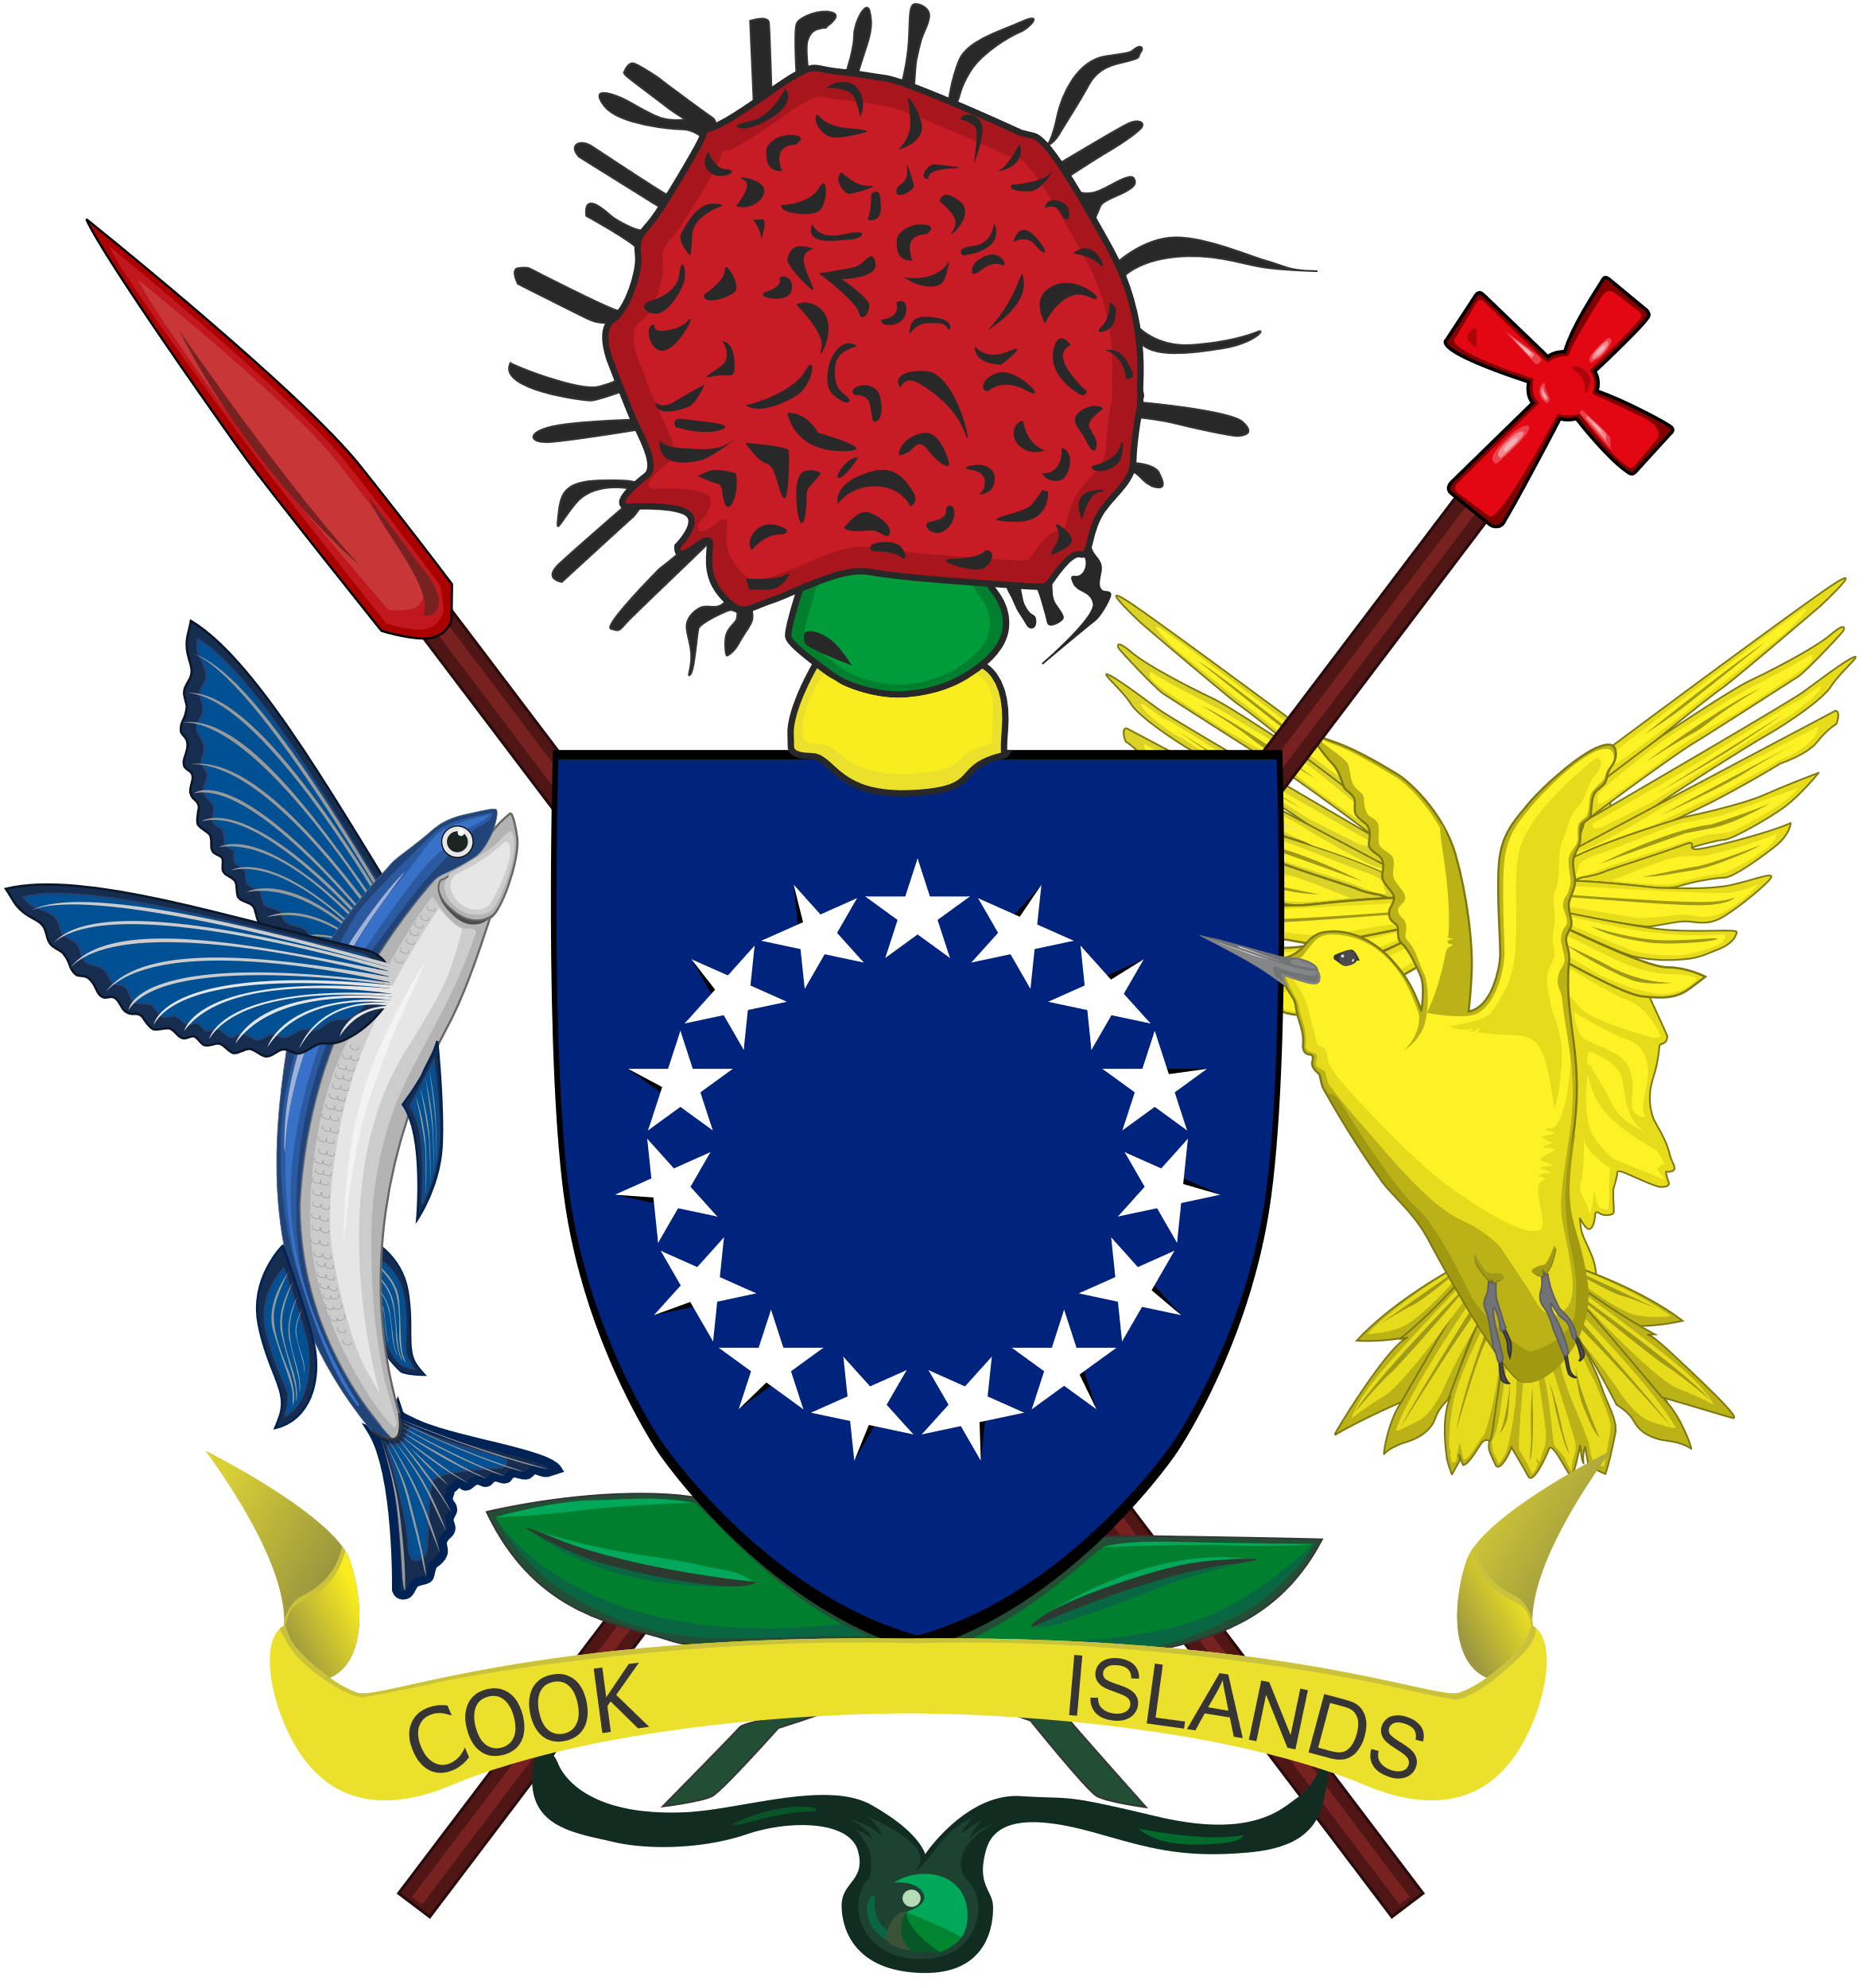  Office of the Public Expenditure Review  Committee and Audit (PERCA). | - Undertaking all audits in order to provide comfort as to the reliability of systems and procedures and the integrity of the information produced.  - Pursuing issues of public concern that affects the management of public funds.  - conducting audits, investigations and enquiries into matters referred to it by the Committee  - Ensuring that Heads of Department have complied with their financial management obligations under the Act. | Complaints in relation to exercising the responsibilities imposed by the Legislation administered by the Office of the Public Expenditure Review Committee and Audit.  These may also relate to the incorrect implementation of the Policies and Procedures imposed under legislation jurisdiction.  Legislation  - PERCA Act 1995-96  - PERCA Amendment 2020  Nature of Complaints  - Misuse of public funds and resources by public officials.  - Purchasing and tender irregularities.  - Financial mismanagement.  - Conflicts of Interest.  - Misuse of Government assets. | Director of Audit – Desmond Wildin  Phone : +(682) 21 231  Email: desmond.wildin@cookislands.gov.ck  Postal address: PO Box 659, Audit Office, Avarua, Rarotonga  Location: Takuvaine Road, Avarua, Rarotonga, Cook Islands  Downloads  - Cook Islands Audit Office Special Review Manual  - Audit Office – Complaints’ submission form  Note: These two items to be linked to new MFEM Website once complete.
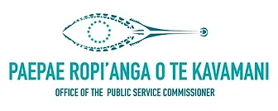  Office of the Public Service Commissioner  Paepae Rupi’anga o te Kavamani | Statutory functions include: recruitment and performance management of Heads of Departments (Ministries), establishing personnel policies and standards for the public service, approving organisation staffing structures, determining the salary ranges of public service positions and administering the remuneration system of Government, ensuring compliance with the public service code of conduct, resolving employment disputes, inquiring into matters of public administration, providing advice on training and career development, reviewing the machinery of government and tendering advice to Ministers of the Crown. Other services include: advice on departmental planning and reporting; administering heads of department salaries, leave and official duty travel, including the New Zealand Government Superannuation Fund. | The legislated function for the Office of the Public Service Commissioner is to assist the administration of the Public Service Act 2009.  - Breaches of the Public Service Code of Conduct of all Heads of Ministries and Departments.  - Conduct of Leaders of the Public Service or Crown entities .  - Poor or sub-standard service delivery or public administration.  - Breaches of Public Service operational policies i.e., Recruitment.  - Employment disputes/  Note: Complaints regarding the conduct of Public Sector employees should be reported to the respective Head of Ministry, Department or Agency the employee works at. | Public Service Commissioner  Phone: +(682) 29 421  Email: pscinfo@cookislands.gov.ck  Postal address: PO Box 24, Rarotonga, Cook Islands  Location: Avarua, Rarotonga, Cook Islands  Website: www.psc.gov.ck  Downloads  - Office of the Public Service Commissioner – Complaint Form
Office of the Ombudsman  Te Mato Akamoeau | The Ombudsman is an independent and impartial officer of and responsible to Parliament. The Ombudsman investigates complaints received from the general public, but is also mandated to initiate an investigation of his own motion. It is also responsible for investigating complaints under the Official Information Act, Disability Act and the Police Act. It was tasked by Cabinet to set up a Human Rights mechanism within the Cook Islands. | The Ombudsman investigates complaints received from the general public, but is also mandated to initiate an investigation of his own motion for:  - Decisions or recommendations relating to a matter of administration.  - Acts or omissions relating to a matter of administration.  - Refusal, charges, manner of release, imposition of conditions of use for information requested under the Official Information Act (OIC).  - Unlawful discrimination against a person with a disability.  - Acts, decisions, omissions, recommendations, conduct, policy and procedure of the Cook Islands Police.  Legislation  - Ombudsman Act 1984  - Official Information Act 2008  - Disability Act 2008  - Police Act 2012 | Phone: +(682) 20 605  Email: ombudsman.complaints@cookislands.gov.ck  Postal address: PO Box 748, Avarua, Rarotonga, Cook Islands  Location: 1st Floor, TJ Browne Building Taputapuatea, Avarua.  Website: www.ombudsman.gov.ck
Crown Law Office  Te Akinanga o te Ture | The Crown Law Office is a statutory organisation whose principal functions are to advise the Government of the Cook Islands on legal matters that may be referred to it by the High Commissioner, Cabinet, a Minister, the Ombudsman a head of department, or a statutory body or Corporation. The head of the Crown Law Office is the Solicitor-General, the Junior Law Officer of the Crown. | Advise Government of the Cook Islands on legal matters that may be referred to it by:  - The High Commissioner  - Cabinet  - A Minister  - The Ombudsman,  - Head of Department  - Statutory Body or Corporation  Legislation  - Crown Law Office Act 1995 | Phone: +(682) 29 337  Email: crownlaw.admin@cookislands.gov.ck  Postal address: PO Box 494, Avarua, Rarotonga, Cook Islands.  Location: Crown Law Office, Ministry of Justice grounds, Avarua.  Website: www.crownlawcookislands.co.ck

